Cheat Sheet

* Deadlocks:

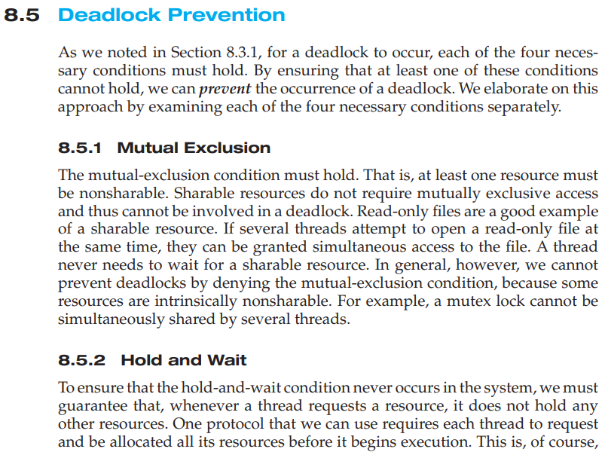

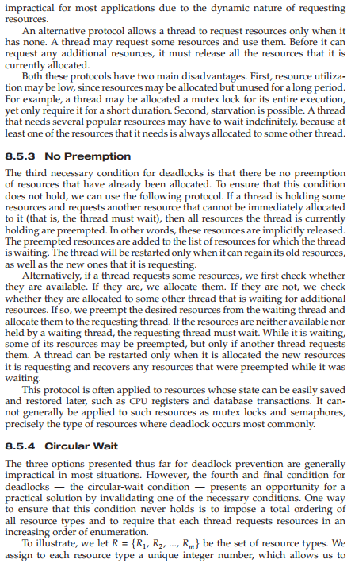

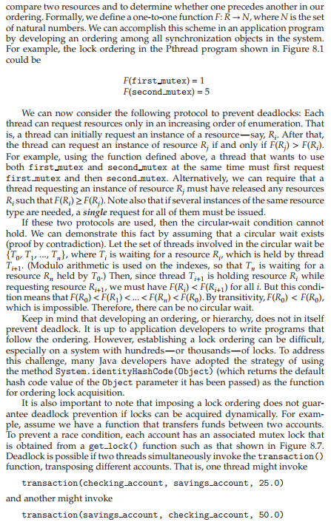

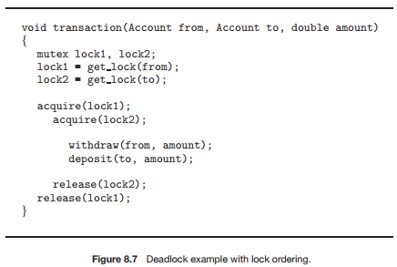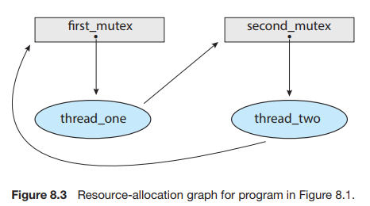

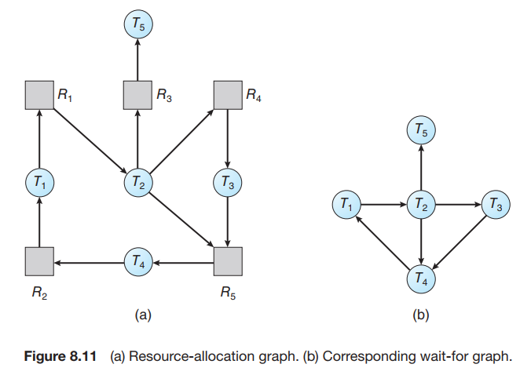

* Memory Management:

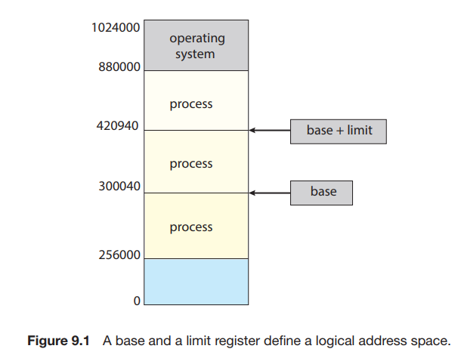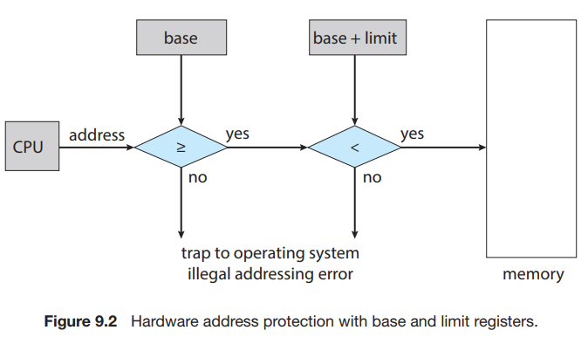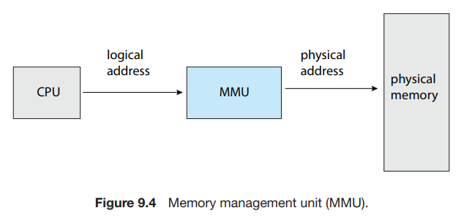

An address generated by the CPU is commonly referred to as a logical address, whereas an address seen by the memory unit—that is, the one loaded into the memory-address register of the memory—is commonly referred to as a physical address.

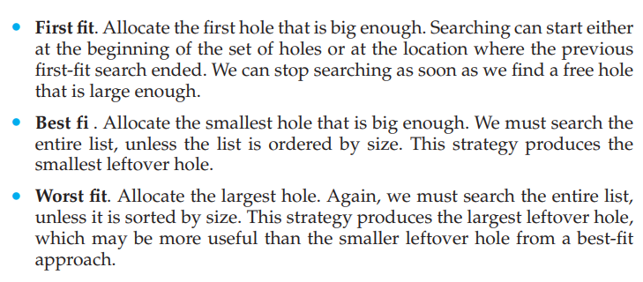

Both the first-fit and best-fit strategies for memory allocation suffer from **external fragmentation**. As processes are loaded and removed from memory, the free memory space is broken into little pieces. External fragmentation exists when there is enough total memory space to satisfy a request but the available spaces are not contiguous: storage is fragmented into a large number of small holes.

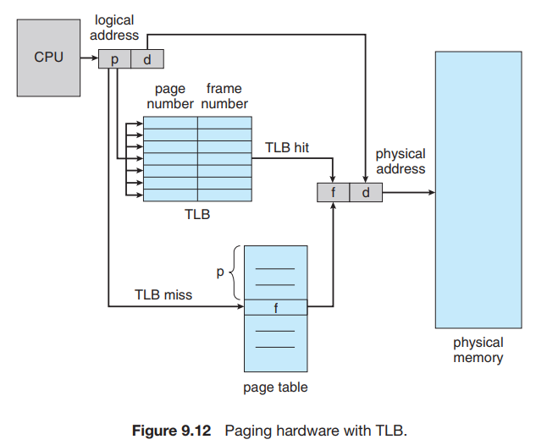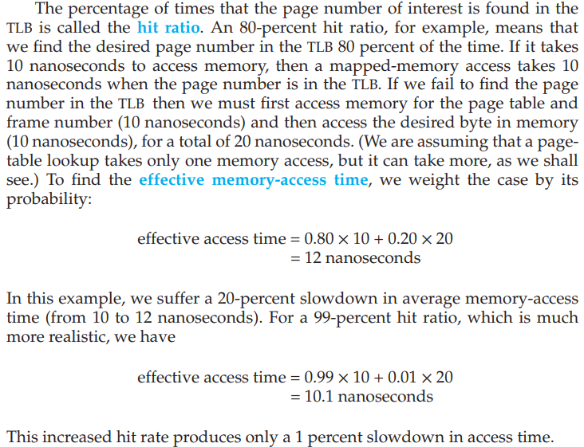

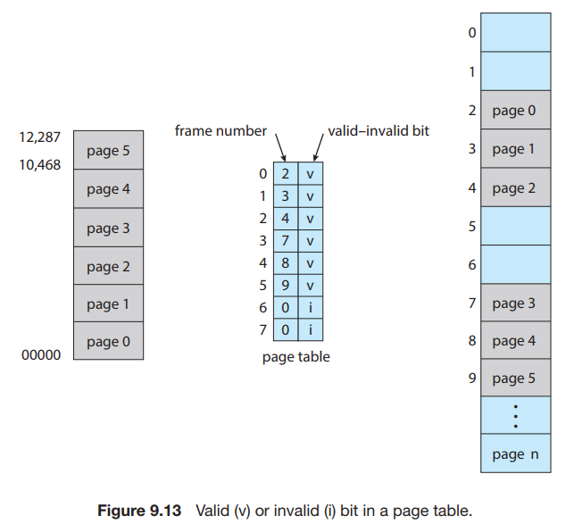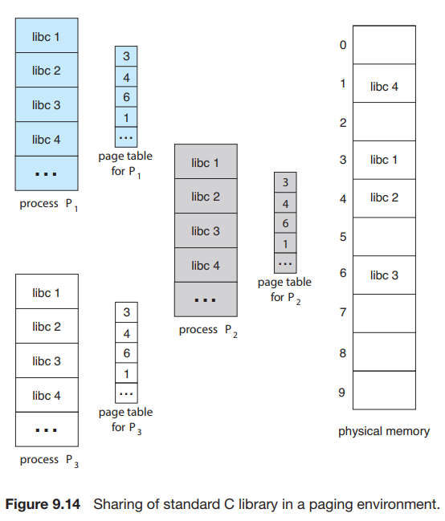

Furthermore, recall that in Chapter 3 we described shared memory as a method of interprocess communication. Some operating systems implement shared memory using shared pages.